**Past Journey To The Past Of Edo Period With Flower Season**

*Attention:*

-Departure: HaNoi.

-Time: 6 ngày 5 đêm.

-Vehicle: aircraft

-Tour price: 38900000đ.

-Images:

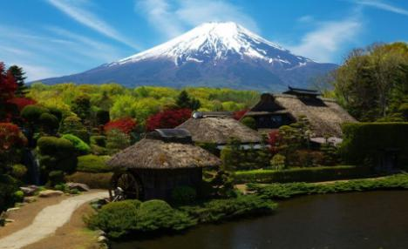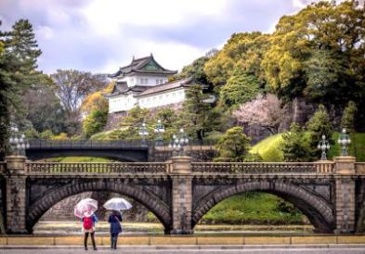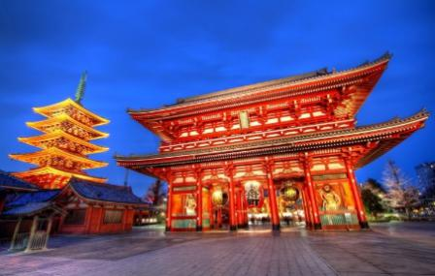

**I.Introduce:**

**Retrospective of Edo Period with Japanese Cherry Blossom Tour**

**Coming to Japan, you will discover the attractive tourist destinations Nikko - Tokyo - Fuji - Hamamatsu - Kyoto - Osaka:**

**Discover the unique traditional cultural beauty and watch cherry blossoms in Japan's largest cities**

**Explore the heritage city of Nikko - the hidden gem among majestic mountains History goes back to Edo Wonderland, where the golden years of the Edo period are proud Enjoy the tulip carpet and cherry blossoms simultaneously blooming in the warm weather in the land of mourning**

**Admire the beauty of Mount Fuji - the symbol of Japan**

**Experience the Onsen hot spring bath**

Discover exquisite cuisines typical of different regions of Japan

Buy out for high quality Japanese domestic goods

Five with your family to experience a meaningful and memorable vacation in Sunrise Country.

**II.Tour schedule:**

**1.Day 1:**

**HaNoI - HANEDA (TOKYO)** _____________________________________________________________________

05:00 You gather at the point to welcome the city center. Vehicles and HDV of the company take you to Noi Bai airport, check in procedures, take flight VN384 at 08:25 to Tokyo, Japan at 15:05

After entry procedures, the delegation moved to Nikko - the city of the hidden gem in the majestic mountains.

Overnight at Ichiryu Kakuhonkan hotel or similar. Guests have experience the traditional Japanese hot spring bath at the hotel. _____________________________________________________________________

**2.Day 2:**

**WONDERLAND EDO - IMPRESSIVE EDO magnanimous** _____________________________________________________________________

Morning: After breakfast at the hotel, visit Edo Wonderland - the golden years - the most attractive theme park in Japan. Edo Wonderland is impressed by the reenactment of the views of the magnificient Edo era, including residential areas, old streets and Samurai residences. Visitors can see the people of Edo with traditional costumes walking, bringing a sense of authenticity and fun. In addition, the shows here will bring the images of the beautiful Geisha, the brave Samurai, .. closer to visitors.

In the afternoon: the delegation will visit Nikko Toshogu Temple - one of the most sacred temples in Phu Tang, which is like a jewel hidden in the towering pines. Because this is a beautiful building imprint of time with many intricate carvings of Japanese architectural style. This 400-year-old temple is dedicated to the famous Shogun Tokugawa, a UNESCO World Heritage Site, and is classified by the Japanese government as a national treasure group to be preserved.

After that, the delegation moved to Tokyo to freely shop for electronics, home appliances, and cosmetics made in Japan at the electronics paradise Akihabara, or the busy Ginza shopping center with thousands of items. fashion cosmetics.

Overnight at hotel Monday Toyosu or equivalent. _____________________________________________________________________

**3.Day 3:**

**TOKYO – JAPAN'S HEART** _____________________________________________________________________

Morning: After breakfast at hotel, transfer to visit Asakusa - Sensoji Temple. Built in 628, worshiping Guan Yin Buddha, the temple is known as the oldest and most visited Buddhist temple in Tokyo for the sacredness and good luck of the prayers. Hope for health, love, study and career. The road leading to the bustling main hall with dozens of traditional souvenir shops gives you a Japanese experience. Then from Asakusa Temple, the group took a picture with Tokyo Skytree - the tallest TV tower in the world.

Afternoon: Visit and take souvenir photos in the Royal Palace - the residence of the Emperor and his royal family.

Depart to Lake Kawaguchi area - a beautiful lake in the system of five lakes at the foot of Mount Fuji. Especially when spring comes, you can both admire the scenery of Japanese spring, and can take pictures with the majestic Mount Fuji behind.

Overnight at hotel in Hamamatsu area _____________________________________________________________________

**4.Day 4:**

**HAMAMATSU EXCITING SPRING COLORS** _____________________________________________________________________

**Morning**: After breakfast, transfer to Hamamatsu Park. By the end of March to mid-April, here if you look up, you will see cherry blossoms in full bloom. Beneath the cherry trees are thousands of blooming tulips. Pink cherry blossoms blooming in the soft blue sky, creating a beautiful view.

**Afterwards**, the delegation enjoyed shopping at AEON Department Store, the leading Japanese supermarket system, where visitors can shop a wide variety of goods, from household goods, cosmetics, and clothing to. daily necessities.

**Next**, the delegation to visit and see cherry blossoms in Hikone Castle Park - one of the five castles listed as a national treasure of Japan. This is the ideal place to watch the blooming cherry blossoms with hundreds of blooming flowers spread along the moats around Hikone Castle, creating an impressive scenery and becoming a popular attraction. Tourists come to visit.

**Overnight** at Hikone View Hotel or similar.

(*The types of flowers are easily affected by weather conditions and the situation of blooming flowers, the flower viewing spots may change)*. _____________________________________________________________________

**5.Day 5:**

**THE ACHIEVEMENTS OF KYOTO, OSAKA** _____________________________________________________________________

**Morni:** After breakfast at the hotel, the delegation moved to visit **Thanh Thuy Pagoda**

**Kiyomizu-dera** -Built in 778, **Kiyomizu Temple** is located halfway up the mountain, the temple attracting the largest number of visitors in the **ancient capital of Kyoto**. The temple is famous for its extraordinary wooden structure that has been recognized by **UNESCO** as a world cultural heritage. It is not only a charming landscape but also a sacred place that attracts locals and tourists to pray for good luck, health, and predestined relationships.

Next, the delegation visited **Kim Kinkaku-ji Temple,** which is known as one of Kyoto's famous tourist symbols, with two floors of floors covered in delicate gold leaf, striking in the middle of the campus. Purely changing with the four seasons, **Kinkaku-ji Temple** silently reflects on the clear lake, bringing in the beauty of a flourishing time of the ancient capital.

**Afternoon:** Bus tour to visit the majestic, **majestic Osaka Castle** - located in the most famous ancient city in Japan with gilded details and turquoise tile color.

After that, if time permits, the group will experience shopping at the most vibrant Shinsaibaishi walking shopping street in Osaka with high quality Japanese domestic items and attractive promotions.

**Overnight** at hotel near Kansai International Airport.

_____________________________________________________________________

**6.Day 6:**

**OSAKA – Hanoi** _____________________________________________________________________

Car and HDV take the delegation to Kansai International Airport to take the flight at 10:30 return to Hanoi. The aircraft landed at Noi Bai International Airport at 13:10. Bus transfer to the meeting place in the city center. The program wraps. _____________________________________________________________________

**III.INCLUDED AND TERMS:**

**Price of tou includes:**

Vietnam - Japan round-trip airfare

High quality scheduled shuttle bus

Hotel 3 - 4 * (double / triple room)

HDV Vietnamese enthusiasm and experience

Meals program (JPY 1,500 - JPY 2,000 per meal)

Sightseeing tickets scheduled

Cost for visa & invitation from Japan

International travel insurance in Japan

40kg checked baggage, hand luggage

**Price does not include:**

Tip for guide and driver (3500 JPY equivalent to 35 USD / person / tour)

Personal expenses, drinks

Other expenses incurred outside the program

Single room surcharge for unregistered guests in case of non-transplantation.

**Tour price for children:**

Under 2 years: 10% (Parents take care of eating and sleeping by themselves)

From 2 years old to under 7 years old: 80% of the tour (sharing bed with parents)

From 8 to 11 years old: 95% of tour price (with own bed)

From 12 years and older: 100% of the tour